Cardinia Shire Council

Disability Action Plan 2021–26

Easy Read version

How to use this plan
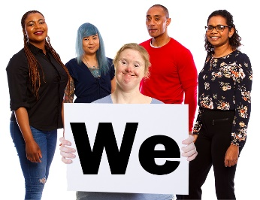 | Cardinia Shire Council wrote this plan.  When you see the word ‘we’, it means the  Cardinia Shire Council.
We wrote this plan in an easy to read way.
We use pictures to explain some ideas.
We have written some words in bold.
This means the letters are thicker and darker.
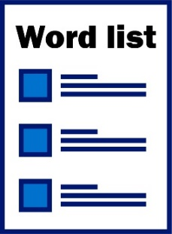 | We explain what these words mean.  There is a list of these words on page XX.
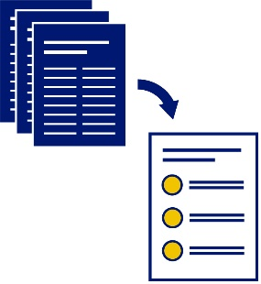 | This Easy Read plan is a summary of another plan. This means it only includes the most important ideas.
 | You can find the other plan on our website at www… .
 | You can ask for help to read this plan. A friend, family member or support person may be able to help you.
We recognise that we live and work on the land
of the:
- Bunurong people
- Boonwurrung people
- Wurundjeri people.

What’s in this plan?
Our vision for Cardinia Shire 5
About Cardinia Shire 6
What do we know about people with disability? 8
The laws that apply 9
What people told us 10
Our Disability Action Plan 12
1. Accessible spaces and places 13
2. Including everyone in our community 14
3. Living, working and learning locally 15
4. Stopping discrimination 17
Making sure our Plan works 18
Word list 19
Contact us 21

Our vision for Cardinia Shire
Our vision is what we want Cardinia Shire to
be in the future.
We want to make Cardinia Shire more accessible.
When something is accessible, everyone can use it.
We want to make Cardinia Shire more inclusive.
When something is inclusive, everyone can take part.
We want Cardinia Shire to be a place where everyone:
- is treated with respect
- can work and learn safely
- feels supported
- has an equal chance to take part.

About Cardinia Shire
112,000 people live in Cardinia Shire.
3,959 people in Cardinia Shire are people
with disability.
By 2031, we will have more than 8,000 people with disability living in Cardinia Shire.
By 2031, we will have about 5,000 older people with disability living in Cardinia Shire.
More than 8,100 people in Cardinia Shire care for:
- a person with disability
- a person with an illness that lasts for a
long time
- an older person
Cardinia Shire is part of the National Disability Insurance Scheme (NDIS).
The NDIS provides support to people with disability all around Australia.
37% of people with disability in Cardinia Shire get supports and services from the NDIS.

What do we know about people with disability?
We know that people with disability face challenges when they:
- look for work
- find a job.
We know that people with disability who get a chance to learn can:
- learn skills for day-to-day life
- find and keep a job
- do things on their own.
We know people with disability are not as safe as other people.
We know that people with disability are treated unfairly because of their disability.
We know it’s important for people with disability to live in a community:
- that includes everyone
- where they can connect with other people.

The laws that apply
We have a law in Victoria called the Victorian Disability Act 2006 (the Act)
The Act explains the rules everyone must follow.
The Act makes sure people with disability in Victoria are treated fairly.
The Act says we must have a Disability Action Plan.
We call it our Plan.
We also follow the National Disability Strategy.
The National Disability Strategy is a plan to make life better for people with disability around Australia.
We also follow the United Nations Convention on
the Rights of Persons with Disabilities (the UN Convention) in our Plan.
The UN Convention is a document that sets out the rights of people with disability around the world.
Rights are rules about how everybody should be treated fairly.

What people told us
We asked people to share their ideas about how Cardinia Shire can be more:
- accessible
- inclusive.
These people were from:
- the Cardinia Shire community
- our team.
They told us by:
- coming to meetings
- visiting our website
- answering our questions.
People shared their ideas about:
- accessible spaces and places
- having a strong community.
- working and learning in Cardinia Shire.
We have included their ideas in our Plan.

Our Disability Action Plan
Our Plan talks about how we will make Cardinia Shire more:
- accessible
- inclusive.
Our plan has 4 themes.
Themes are important ideas that come up in different areas of our work and lives.
- Accessible spaces and places
- Including everyone in our community
- Living, working and learning locally
- Stopping discrimination.
Discrimination is when you treat someone
badly because of something about them they
can’t change.
We have a list of what we need to do to reach our goals for each theme.
We talk about each theme in more detail on the following pages.

1. Accessible spaces and places
We can include people with disability if our places and spaces are accessible.
This includes our:
- public spaces
- services
- businesses.
We will make sure people with disability can find and use local services.
We will make all our buildings more accessible.
This includes:
- new buildings we make
- buildings we already have.
We will make our outdoor spaces more accessible.
This includes our:
- parks
- footpaths.
We will make local businesses more accessible.

2. Including everyone in our community
When our community is inclusive, people with disability can:
- feel supported
- connect with other people
- take part in fun activities, like sport.
We will make sure our community knows more about people with disability.
We will make sure our local businesses know more about people with disability.
We will make information accessible for everyone.
We will give people with disability more chances to take part in:
- sport
- community events
- community groups.

3. Living, working and learning locally
When people with disability work, they can:
- earn their own money
- connect with other people
- take part in the community
- feel like they belong
- do more for themselves and on their own.
We will give people with disability more chances to:
- learn
- find work and keep a job.
We will celebrate when people with disability reach their goals.
We will become leaders of hiring more people with disability.
We will speak up about giving people with disability choices about:
- where they live
- who they live with.

4. Stopping discrimination
When we stop discrimination, people with disability can feel:
- safe
- included
- respected.
We will help our community change what they:
- think about people with disability
- believe about people with disability.
We will celebrate our diverse community.
When our community is diverse, it means lots of different people live there.
We will make sure people with disability feel:
- safe
- welcome.

Making sure our Plan works
We will keep track of how well our Plan is going.
We will make sure it:
- includes how we reach our goals
- stays up to date
- meets the needs of people with disability.
We will write a report about our Plan each year.
Our Plan will last for 5 years.

Word list
Accessible
When something is accessible, everyone can use it.
Discrimination
Discrimination is when you treat someone
badly because of something about them they
can’t change.
Diverse
When our community is diverse, it means lots of different people live there.
Inclusive
When something is inclusive, everyone can take part.
National Disability Insurance Scheme (NDIS)
The NDIS provides support to people with disability all around Australia.
National Disability Strategy
The National Disability Strategy is a plan to make life better for people with disability around Australia.
Rights
Rights are rules about how everybody should be treated fairly.
Themes
Themes are important ideas that come up in different areas of our work and lives.
Vision
Our vision is what we want Cardinia Shire to
be in the future.

Contact us
1300 787 624
mail@cardinia.vic.gov.au
Cardinia Shire Council
Civic Centre
20 Siding Avenue
Officer
VIC 3809
www.cardinia.vic.gov.au

The Information Access Group created this Easy Read document using stock photography and custom images. The images may not be reused without permission. For any enquiries about the images, please visit www.informationaccessgroup.com. Quote job number 4118.

