Access and Inclusion

Disability Strategy and Action Plan

2021 – 2026.

Prepared by Emily Tuck and Annmarie Saffin
Cardinia Shire Council
Liveable Communities, Community and Family Services, Access and Ageing
Access and Inclusion – Disability.

Published January 2021
© Cardinia Shire Council 2021
ABN: 32 210 906 807

20 Siding Avenue, Officer
PO Box 7, Pakenham Vic 3810
(DX 81006)
Phone: 1300 787 624
Email: mail@cardinia.vic.gov.au
Web: cardinia.vic.gov.au

Contents

1 Acknowledgements 4
2 Mayors Forward 4
3 Introduction 5
4 Background 6
4.1 Cardinia Shire Access and Inclusion Committee 7
5 Our Community 8
6 Population Data - Disability 9
6.1 Demographics 9
6.2 Health 10
6.3 Employment 10
6.4 Education 11
6.5 Safety 11
6.6 Carers 11
6.7 Housing 12
6.8 Legislation 12
6.9 National Disability Insurance Scheme (NDIS) 13
7 Policy Context 14
8 Community Consultation 14
8.1 Covid-19 14
8.2 Methodology 14
8.3 Results 16
9 Action plan 18
10 Implementation 18
11 Results page 19

Acknowledgements
Cardinia Shire Council respectfully acknowledges the Bunurong and Wurundjeri people as the traditional owners of the land on which we are today, and we pay our respects to their elders both past and present.
Council appreciates the invaluable contribution from our residents, Councillors, community organisations, service providers, and Council officers who shared their vision, knowledge and experiences during the consultation process and development of this plan.
Council expresses gratitude to the Cardinia Access and Inclusion Committee; The Access and Inclusion Committee Members have been integral in the development of this action plan.
We strive to create a Cardinia Shire where residents can actively participate in their community, regardless of their ability. A community that enables and encourages people, where everyone is valued.

Mayors Forward

Introduction
The Access and Inclusion, Disability Strategy and Action Plan, 2021-2026 is the second disability action plan for Cardinia Shire Council. The 2017/2021 Disability Action Plan had 30 action items that were achieved. This plan builds upon the learnings of the first plan and is underpinned by the Cardinia Shire values of teamwork, respect, accountability, communication, and customer focus along with our culture statement of together, different, future.
Cardinia Shire is an inclusive organisation valuing our community for unique qualities, ideas, and insights. Cardinia Shire acknowledges our community as one that is diverse in age, culture, life experience, gender identity, race, ethnicity, disability, faith, sexual orientation, or other diversities. The disability strategy and action plan mirror this value in recognising that people with disability also experience diversity in various ways.
This strategy and action plan incorporates the intersectionality of our Social Justice and Equity Plan and the vision and objectives within Councils Liveability Plan. The Disability Strategy and Action Plan too aims to deliver for our disability community the vision that “Cardinia Shire will be developed in a planned manner to enable present and future generations to live healthy and productive lives and to enjoy the richness of the diverse and distinctive characteristics of the shire.”
The Access and Inclusion, Disability Strategy and Strategy and Action Plan, 2021-2026 has been developed in the context of fundamental change in the disability community and sector. The National Disability Insurance Scheme Act was legislated in 2013, and subsequent rollout to the Southern Melbourne Area incorporating Cardinia Shire occurred in September 2018. A new national disability strategy is in development and the Royal Commission into Violence, Abuse, Neglect and Exploitation of People with Disability commenced in 2019 and is ongoing. In Victoria consultation is underway for the next state disability action plan 2021-2024. It is also important to recognise the impact of the Bunyip bushfires in March 2019 and the unprecedented challenges presented by the Coronavirus pandemic. These events highlight the importance of considering the needs of people with disability and ensuring inclusion in emergency planning and recovery.
This document outlines Council’s commitment to people with disability having full equity, inclusion, and participation as they live, work, learn and explore Cardinia Shire. It reflects the changing policy environment and builds upon current and emerging opportunities to be an accessible and inclusive community.
Most importantly “Nothing about us without us” a key ideology of the disability community. This strategy and action plan is developed with Cardinia Shire’s disability community, support and services sector, advocacy groups, committees, educators, carers, and families amongst many other community assets.

Background
Cardinia Shire Council has both ethical and statutory responsibilities to ensure that all people have equal access to services, facilities, and resources within the community. Section 38 of the Victorian Disability Act 2006 states that councils are required to prepare a disability action plan that identifies actions to remove barriers for people with a disability. It is designed to promote inclusion and participation of persons with disability and change attitudes and practices which directly or indirectly discriminate against persons with a disability.
Disability is described by the WHO as "an umbrella term, covering impairments, activity limitations, and participation restrictions”. An impairment is a problem in body function or structure. Some people are born with a disability, many acquire a disability as a result of an accident, illness, genetic condition or as part of the aging process. A disability may be visible or hidden, permanent or temporary and have minimal or substantial impact on a person’s abilities.
Along with different disability ‘types’ it is also acknowledged that disability may be experienced alongside other barriers to participation such as age, culture, life experience, gender identity, race, ethnicity, disability, age, faith, sexual orientation, or other diversities.
People with disability are part of every section of our community: women, men, and children; employers and employees; students and teachers; indigenous and non-indigenous; customers; refugees and citizens. No two people with the same disability experience their disability in the same way. The only thing that distinguishes a person with disability is they may require some form of adaptation/adjustment to enable them to do certain things in the same way as people without disability. This is equity.
The disability sector and community in Australia have endured fundamental change with the introduction of the National Disability insurance Scheme in 2013. There has been a gradual rollout of the scheme with Cardinia Shire, the City of Casey and the City of Greater Dandenong forming the Southern Melbourne Area in September 2018. The Southern Melbourne Area is forecasted to experience the largest growth in the number of people receiving NDIS supports and concurrently the Southern Melbourne Area will require the largest increase in workforce.
Locally disability reform included rescinding the Metro-Access role and scope of works. Council responded to this with ongoing commitment to resourcing the disability portfolio.
People with disability have a wide range of conditions and impairments. What they have in common is a shared experience of encountering negative attitudes and barriers to full participation in everyday life. The ‘social model of disability’ is based on the understanding that disability is caused by the barriers to participation in community life or that disability is socially constructed, rather than by a person’s own impairment. The social model places the person at the forefront and highlights that it is the environment and/or negative attitudes that are most ‘disabling’ to individuals living with an impairment. It emphasises dignity, independence, choice, and privacy. When the environment and opportunities are presented in a more accessible and inclusive manner, people can be enabled to achieve their best possible health. The social model does not deny the experience or impact of impairment. It does, however, challenge the physical, attitudinal, communication and social environments to accommodate impairment as an expected occurrence of human diversity. This is the impetus for having a strong disability strategy and action plan.

Cardinia Shire Access and Inclusion Committee
In 2005, Cardinia Shire established the Access and Inclusion Advisory Committee (formerly The Cardinia Disability Advisory Committee).
The Committee was established to provide a forum for Cardinia Shire: residents, businesses, and community groups, representing the interests of people with disability in the Local Government Area.
The objectives of the committee are to:
- Monitor, review, and support Council’s disability policy,
- Provide information and advice to council on issues impacting upon people with a disability,
- Participate in strategic planning, and
- Act as ambassadors for the disability community.
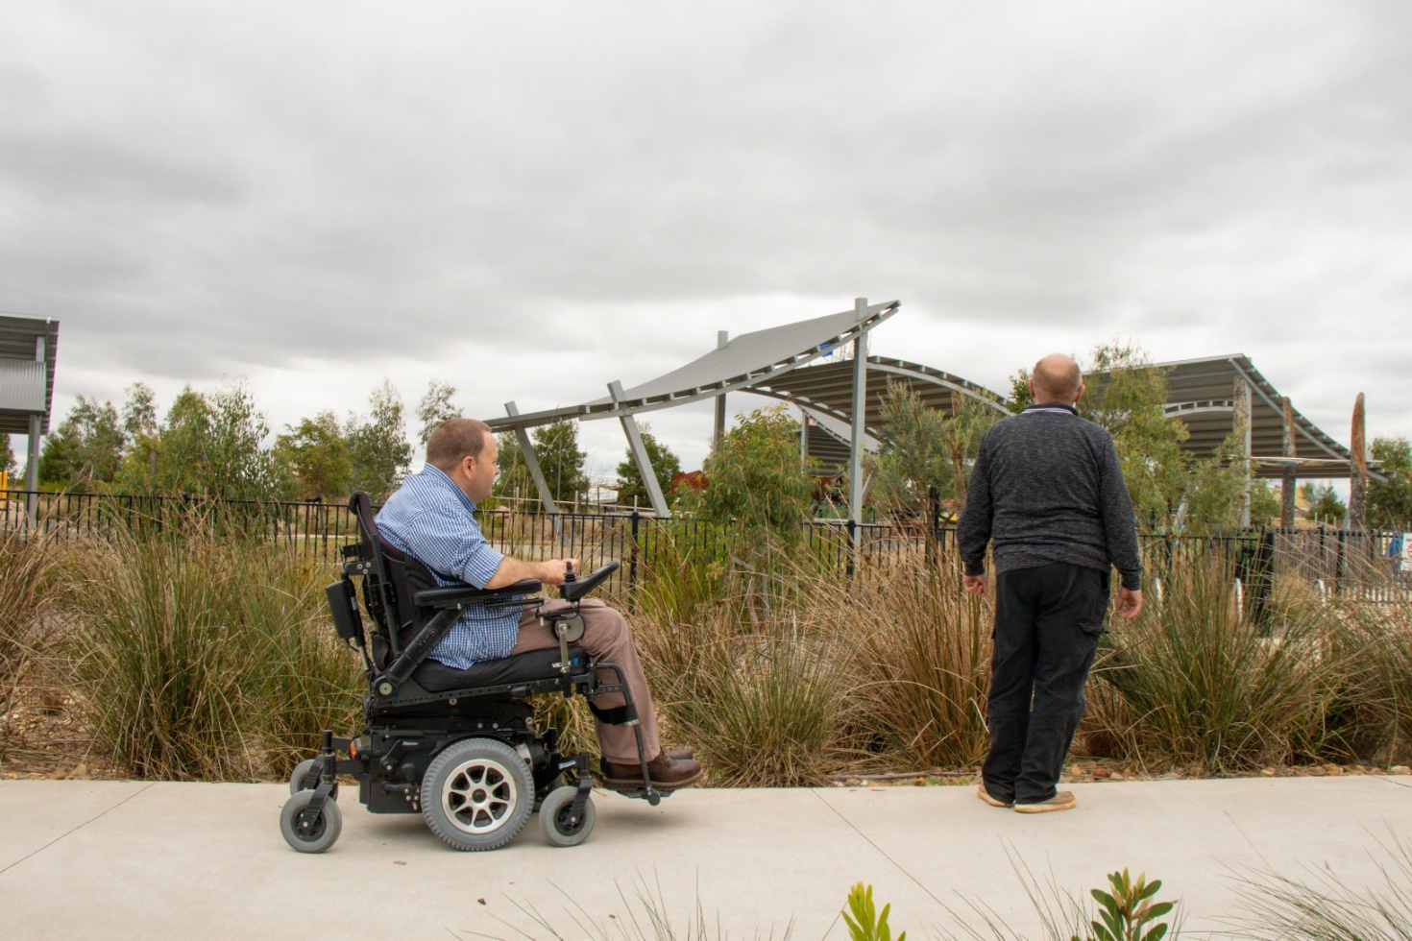
The Access and Inclusion Committee Members have been integral in the development of this strategy and action plan.
Figure 1 Image of Cardinia Access and Inclusion Committee members at Deep Creek Reserve Pakenham

Our Community
Cardinia Shire is located in the south east of Melbourne, about 55 kilometres from the Melbourne CBD and is where land use transitions from urban rural. Cardinia Shire has an area of 1,281 square kilometres.
Cardinia Shire has diversity of landforms and landscapes. It is bound by the hills of the Yarra Ranges to the north, and Westernport Bay to the south and continues the growth corridor from the City of Casey. It is an area of rapid growth in population and concurrent development.
The 2019 estimated population of Cardinia Shire is 112,159 people and over the next 12 years we expect this to increase by 60 per cent to a total of 179,657 people. The majority of Cardinia Shire’s population is located within the growth areas of Beaconsfield, Officer and Pakenham, which will also accommodate the majority of future residential and commercial growth . It is forecasted that Cardinia will experience significant population growth over the next twenty years. Reflecting this trend will be a corresponding increase in the number of our residents living with a disability.
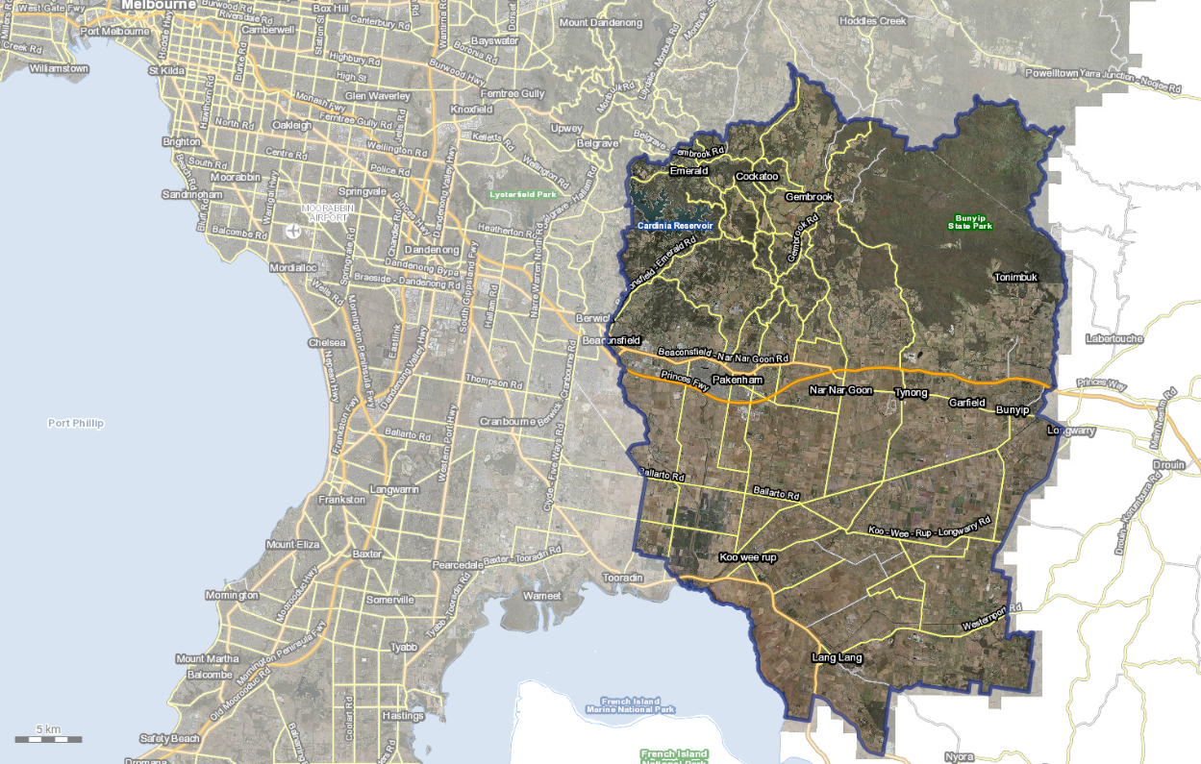
Figure 2 Cardinia Shire aerial map. Source Near Maps, 2020

Population Data - Disability

Demographics
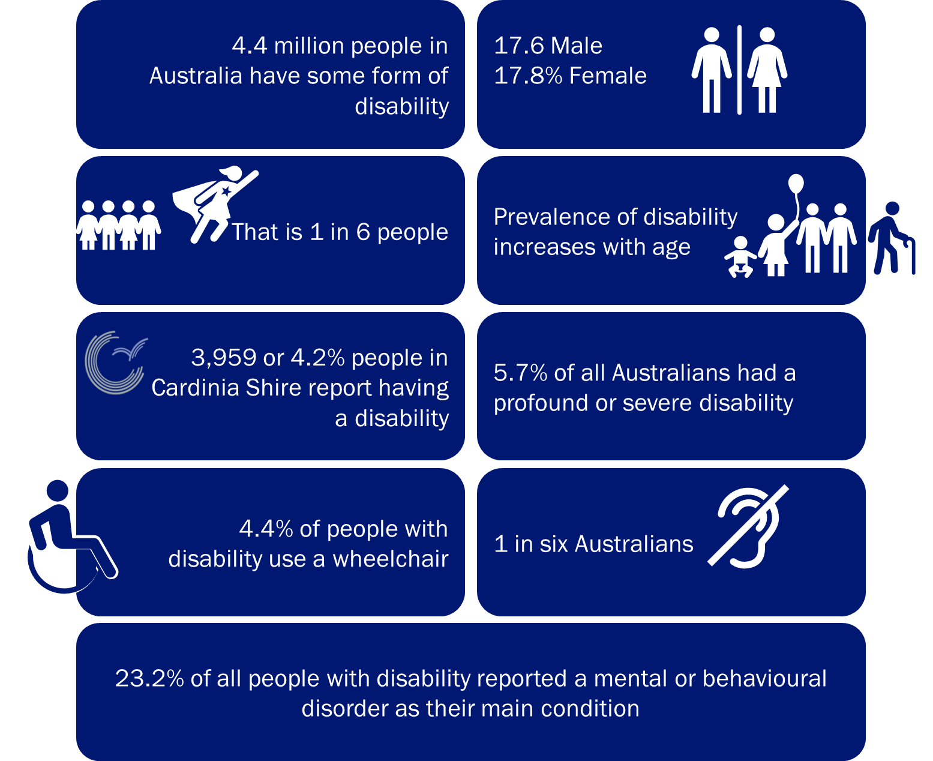
The disability population is diverse. It encompasses people with various types of disability across all age groups, socioeconomic and demographic groups. The experience of disability is also diverse, people with the same disability do not experience their disability in the same way.
There are 4.4 million people who have disability in Australia. That is, 1 in 6 people. 5.7% of the Australian population experience profound or severe disability. This means sometimes or always needing help with daily self-care, mobility, or communication activities.
In 2019, Cardinia Shire was home to almost 4,000 residents who have disability. Statistics is a summary of disability statistics in Australia.
Figure 3 Disability Statistics
The Australian population is getting older, and disability prevalence increases with age. People over 65 years account for 50% of people who have a disability. In 2030, Cardinia Shire is forecasted to have 8,404 residents with a disability an increase of 82%. More than 5,048 or 60% of all Cardinia Shire residents with disability will be above 65 years (Figure 4).
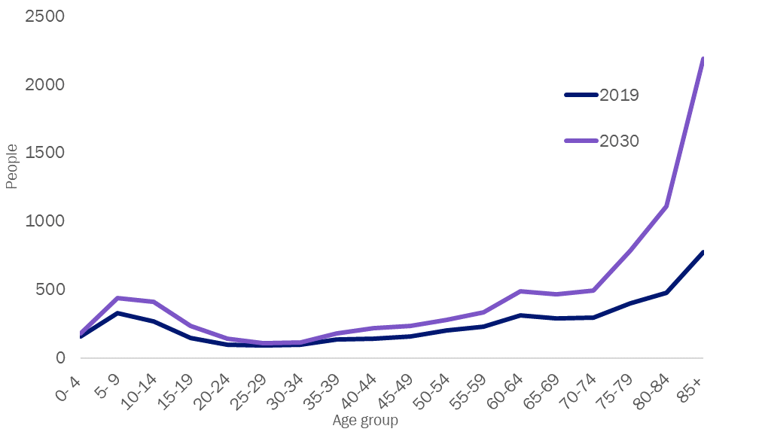
Figure 4. Cardinia shire prevalence of disability by age group, Comparison 2019 - 2030

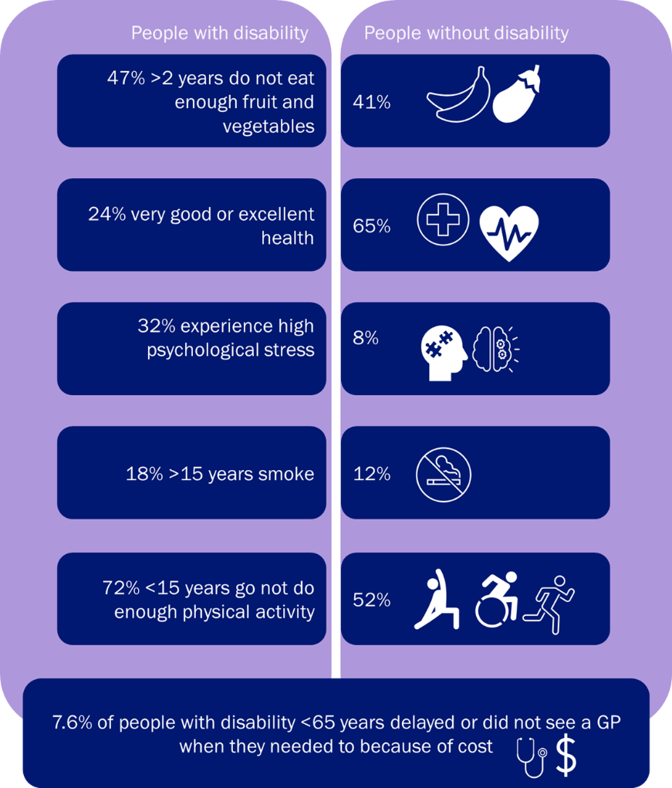
Health
The relationship between health and disability is complex. Long term health conditions can lead to disability, and disability can contribute to health problems. The nature and type of disability can influence health states, disability can lead to limited access to and participation in social and physical activities.
People with disability report poorer general health and higher levels of stress than people without disability, they also have higher rates of modifiable risk factors such as poor diets, smoking, less exercise, and experience barriers to accessing health services. Figure 4 provides a summary of health disparity between people with and without disability.
figure 5 heath disparity statistics for people with and without disability.

Employment
People with disability face challenges seeking and engaging employment. Paid work builds self-worth and independence. The unemployment for people with disability is double (10%) when compared to people without disability (5%). People with disability are often underemployed and would like to work more hours. Underemployment means earing less and exclusion from opportunities to participate in the community.
Cardinia Shire Council has a role to ensure our recruitment practices are inclusive, ensuring our vacancies reach people with disability and disability employment agencies and that our reasonable adjustment policies are current.
Council also has a role in promoting disability awareness training to build capacity within our business community to engage with people with disability and disability employment agencies.

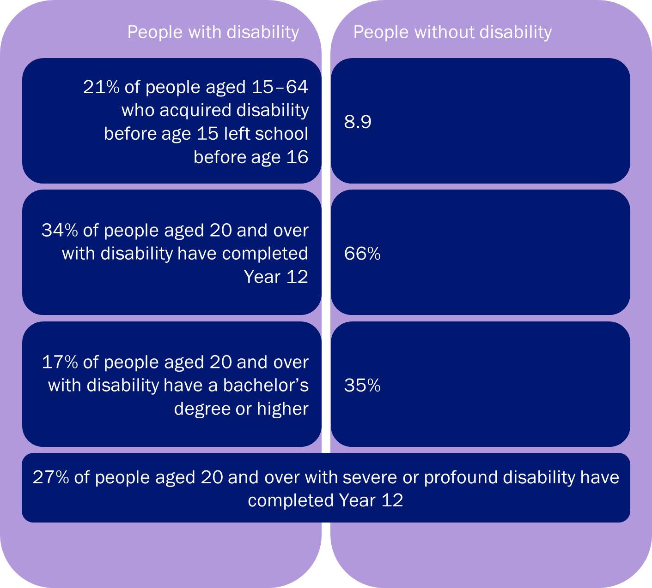
Figure 6 Education statistics, variation between people with and without disability

Education
Education is about attaining knowledge and life skills to participate in day to day lining. Having a higher level of education attainment is associated with greater employment outcomes, higher income and self-worth, security, and independence. Figure 6 Education statistics, variation between people with and without disability provides statistical information about disability and the education system.

Safety
People with disability can experience higher rates violence, abuse, neglect, and exploitation than people without disability. Along with this they can also encounter barriers to expressing their experiences and asserting their rights. The Royal Commission into Violence, Abuse, Neglect and Exploitation of People with Disability commenced in 2019 and is ongoing. In Cardinia Shire there are an average 4 reports of family violence each day .
Disability discrimination occurs when a person with disability is treated unequally, less favourably, or not given the same opportunities as other people because of their disability. This can be direct like refusing entry to a playground because they have an assistance dog or indirect where steps preclude entry to a person using a wheelchair. The disability Discrimination Act 1992 makes it unlawful discriminate or to treat people unfairly because of their disability.

Carers
Carers are people who provide unpaid care and support to people who have a disability, health conditions and or older people. Carers are essential to support our disability community to support with day to day activity and personal care. They also manage any administration and connect to the broader health, emotional and social supports.
There are over 2.65 million carers in Australia, around 240,000 cares in Victoria and. In 2016, Cardinia Shire was home to 8,146 residents who provide care or assistance to a person with disability, long term illness or old age. The average age of a primary carer is 54 . Approximately 45% of carers care for their partner, 24% for their children with care needs, 21% for their parents and 10% for a relative or friend.

Legislation
Cardinia Shire Council is required under section 38 of the Victorian Disability Act 2006 to develop disability action plan. Council must report on the implementation of the Disability Action Plan in its annual report under section 98 of the Local Government Act 2020 .
The disability strategy and action plan sets out the steps that Cardinia Shire Council will take to make the products and services we deliver to the public more accessible and inclusive, as well as outlining the steps Council takes to make our corporate culture and practices more inclusive.
The Disability Strategy and Action Plan is prepared for the purpose of:
- reducing barriers to persons with a disability accessing goods, services, and facilities.
- reducing barriers to persons with a disability obtaining and maintaining employment.
- promoting inclusion and participation in the community of persons with a disability.
- achieving tangible changes in attitudes and practices which discriminate against persons with a disability .

Housing
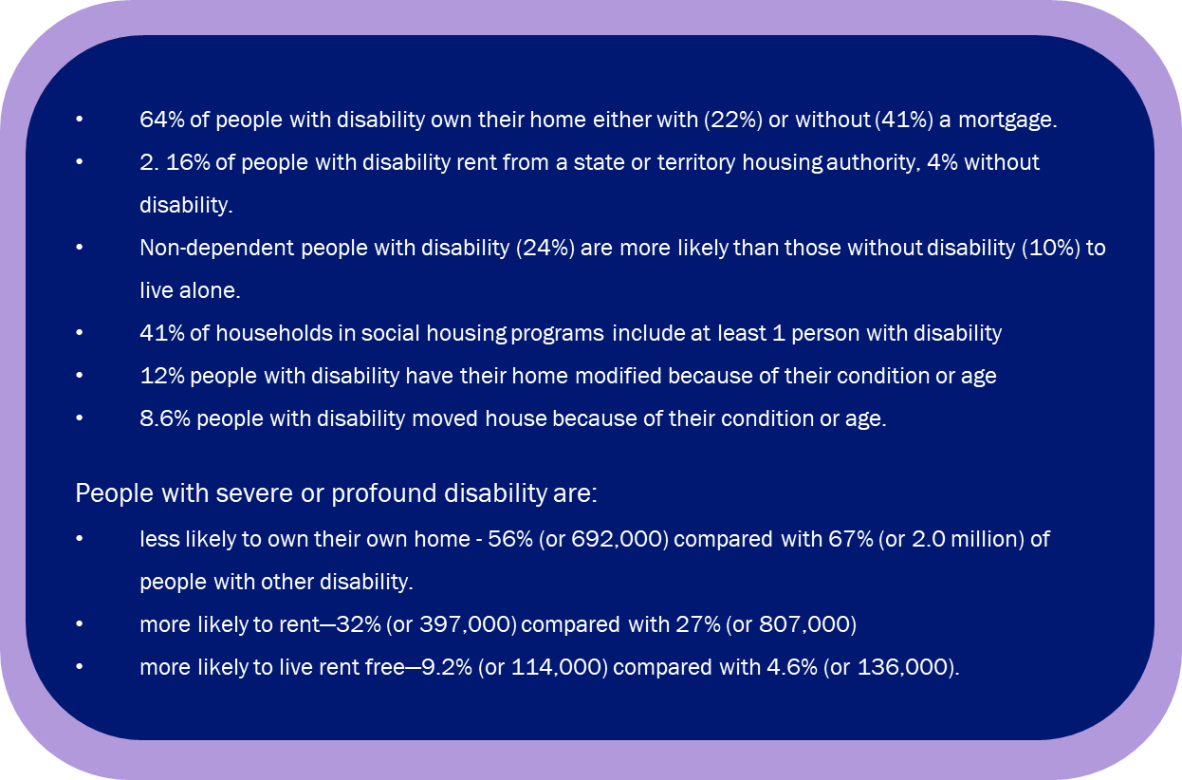Council recognises affordable housing as a human right and an important link to a liveable neighbourhood; critical to creating a ‘liveable, resilient community where the environment flourishes and residents are healthy, included and connected’.

Figure 7. Disability Housing statistics.

A variety of hidden ongoing living costs, particularly transport costs associated with lower residential densities and limited public transport access introduce further affordability issues, with many residents living in greenfield sites at risk of mortgage and rental stress should petrol prices rise. This can be an issue for people with disability, whose households can face other disadvantage in the private market that makes accessing appropriate housing challenging.
Financial vulnerability and housing insecurity can be exacerbated by chronic health, disability, and family violence. Figure 7. Disability Housing statistics. below outlines housing statistics for people with disability.

National Disability Insurance Scheme (NDIS)
Cardinia Shire entered the NDIS in November 2018. The NDIS changed the way people with disability receive and use disability support services. The NDIS gives the funding directly to people with disability who meet the NDIS access requirements of permanent and significant disability. It is designed to get the support people with disability need to improve their skills and independence over time.

For people with disability who do not reach NDIS access, the NDIS provides information and connections to community services. This includes connections to doctors, sport clubs, community social groups, libraries, and schools.
The diagram in Figure 87 summaries the Australian population with disability. There are 25 million Australian’s, 4.4 million Australians have a disability. The NDIS is expected to fund around 500,000 people in Australia to receive the NDIS support they need to improve their skills and independence over time. 11.3% of Australians with a disability receive funded NDIS supports. In Cardinia Shire 37% of residents with disability received the funded NDIS supports. The remaining 63% are supported through the information and connections (informal supports) and mainstream services (formal supports) such as education, healthcare, justice system and others. Because there is a higher proportion of residents with disability as NDIS participants it can be inferred that there is a higher proportion of people with a more significant and profound disability in Cardinia Shire.
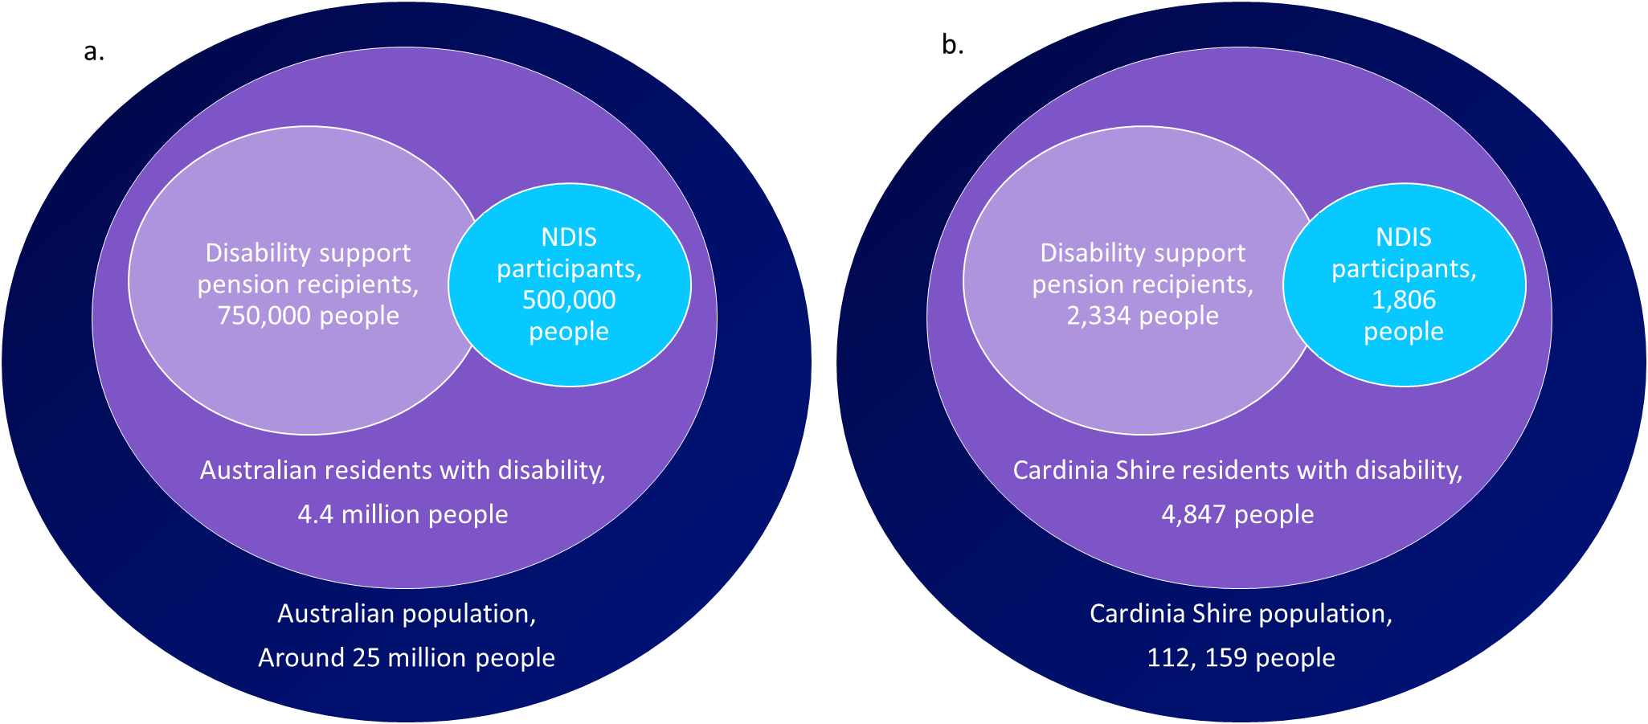
Figure 8. NDIS funded supports a) Australia and b) Cardinia Shire.

Policy Context
Disability action plans are an important local government resources to reduce barriers, promote inclusion and participation and change attitudes and practices.
Cardinia Shire’s access and inclusion disability strategy and action plan is informed externally by international, national, and state-wide strategies and legislation (Figure 9). Internally, strategies and plans that have informed the access and inclusion disability strategy and action plan include the council plan, the liveability plan, and the social justice and equity plan (Figure 9).

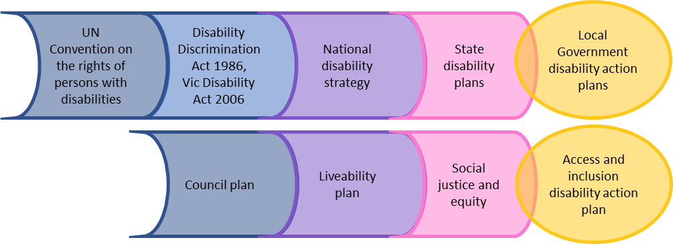
figure 9. Legislation and strategies informing Cardinia Shires’ disability strategy and action plan.

The social justice and equity plan provides a framework to uphold the human rights of our diverse communities and promote the social justice principles of participation, access, and equity in all aspects of community life. It unifies and is supported by a suite of actions that focus on specific areas of diversity including:
- Disability
- Reconciliation
- Cultural diversity, and
- LGBTIQ+
The Council Plan outlines the priorities and steps required to deliver the long-term council vision. It correlates with the Liveability Plan, which is Cardinia Shire’s municipal public health and wellbeing plan, a legislative requirement under the Victorian Public Health and Wellbeing Act 2008. The relationship between to the two plans and the disability strategy and action plan are listed in Figure 10 below:
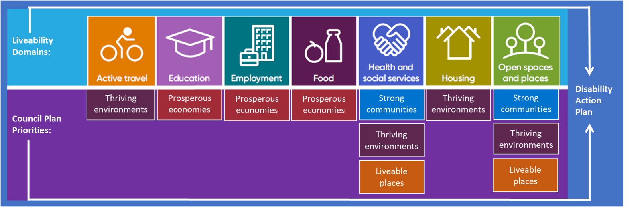
Figure 10 Liveability Plan domains overlayed with Council Priorities

Community Consultation

Covid-19
Covid-19 has deeply impacted communities around the world. Victoria has had additional challenges imposed by the restrictions in relation to coronavirus. Delivering a successful strategy and action plan is dependent upon engagement with the disability community and sector.
The impact of coronavirus delayed consultation for the:

- National Disability Strategy
- State Disability Plan
- Review of the Victorian Disability Act 2006
The delays and concurrent consultations have impacted the timing of community consultation and engagement for the Access and Inclusion Disability Strategy and Action Plan 2021-2026. The community engagement was delayed by 4 months to meet our legislative requirements and has given the disability community and sector time to recover. This has provided an opportunity for the Cardinia Shire community to contribute meaningfully to create a plan that is relevant, reflective, and effective. However, the results must be considered with following Covid-19 confounding factors:
- Over consultation and consultation fatigue
- High likelihood of under representation from the disability community and sector due to the
impacts of Covid-19 on their day to day lives and operations
- Confounded results, outcomes, and views, overshadowed by the effect of Coronavirus

Methodology
The key deliverable of the project is development a disability strategy and action plan informed by our community and Council that sets out what we will do to make our workplace, services, programs and community more accessible to people with disability ensuring they are equitable, inclusive, and safe. This was achieved by a range of engagment activities and a concurrent communication plan.
The engagement activities focused on the AIHW person-centred framework where the the person is central to the surrounding determinants that influence their health and wellbeing. The determinants explored in the engagement activities were education and employment, access and inclusion, and, discrimination.
The engagement opportunities for about the new disability strategy and action plan included:
- Face to face pop up sessions across the shire:
    - Pakenham
    - Koo Wee Rup
    - Deep Creek Reserve
    - Emerald
- Creating Cardinia Web Page, outlining the opptortunities to provite feedback and the strategy and action plan development timeline
- 2 online sessions offered
- Online survey
- Online activity
- Paper surveys
- Face to face sessions at local promary schools
- Internal staff workshop
- Internal Councillor workshop
The concurrent communications about the engament opportunities included:
- Social media posts
- Social media events
- Paid social media advertising
- News paper print advertising
- Emails to disabily comminity sector and community
- Officer specialist school newletter post, 300+ readership
- Mayor of the air radio promotion on ABC Gippsland
- Internal business feed posts
- Business feed calendar entries for events
- Emails to all staff
- Councillor bulleting
- CEO newletters
From the community engagements we received responses from 75 school students, 54 surveys completed and 58 people attended the community pop ups.
The Survey was completed by 54 people, 34% of respondents identify as having a disability, 17% identified as a parent or guardian of a person with disability (for full results, refer to page 11). The community engagement resulted in a total of 655 comments and suggestions for analysis. A breakdown of the engagement activities and themed feedback items is in Table 1 below.
Table 1 Community engagement summary, number of comments, grouped into themes
Engagement activity | Access to good spaces and places | Inclusion and participation | Employment and education | Prevent discrimination | Totals
Survey | 137 | 82 | 112 | 53 | 384
Access and Inclusion Committee | 10 | 12 | 5 | 7 | 34
Councillor workshop | 8 | 7 | 5 | 6 | 26
Council staff workshop | 26 | 12 | 15 | 9 | 62
Primary school engagement | 30 | 21 | 1 | 0 | 52
Sector consultation | 11 | 13 | 10 | 3 | 37
Pop up sessions | 32 | 18 | 6 | 4 | 60
Total | 254 | 165 | 154 | 82 | 655

Results
The community engagement resulted in a total of 655 comments and suggestions for analysis. From these, three strong themes evolved: Liveable places, strong communities, and independence. These three themes link to both our legislative requirements and our Council and Liveability plans.
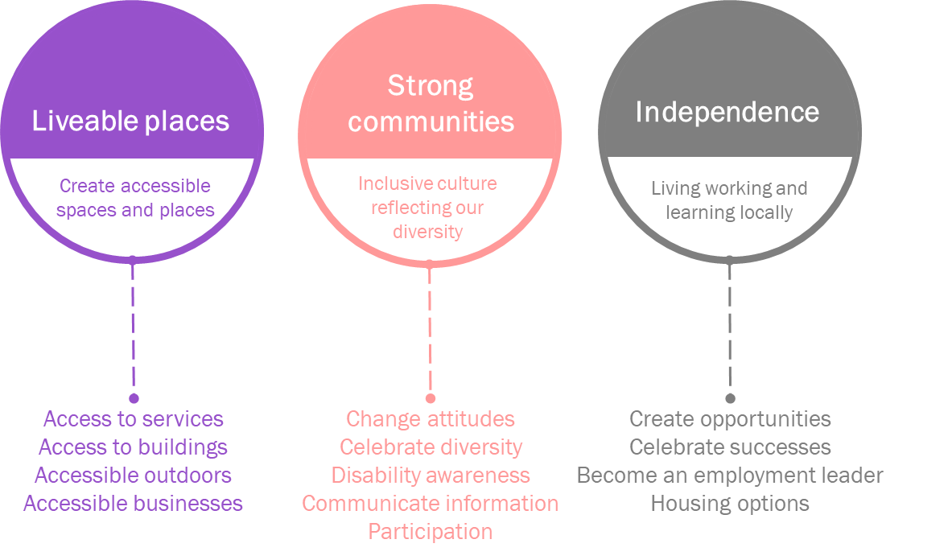
Below are some of the comments from the community, and council engagement grouped into the three themes:
Liveable places:
“People ignore me all the time in the retail / hospitality industry. They'll talk to the person I’m with rather than me.”
“remove physical barriers for accessing all community facilities”
“more accessible car parks with good access to footpaths”
“improved paths and access around the community centre & toilets”
“more seating in streets”
“more easy read council documents”
“develop a statement on universal design”
“provide appropriate facilities for people with disabilities”
Strong Communities:
“People with disability should be included in all our flyers, website etc.”
“storytelling and sharing stories around disability, placements and in social media.”
“encouraging individuals with a disability to participate”
“informing and educating the community about disability (including behaviours), inclusiveness and the ability of a person with disability.”
“acknowledging the diversity of disability, including mental health disability.”
“supporting carers and family to feel comfortable in public places and removing the shame of disability.”
“provide support to sporting and recreation clubs to increase awareness, understanding and culture to make them more welcoming to people with a disability”
Independence:
“I have a high level of intelligence. I use a walker. Apparently, for some people, this equates with stupidity. Not mine, I assure you.”
“applying for jobs, people stare, and people ignore, people don't know how to relate to a person with disability.”
“council to advocate for services to be located in the shire and consider the best way to encourage services into the shire - incentives etc.”
“education program for developers, businesses etc.”
“mentor program for people with disability”
“we should support more people with disability work at council”
“often it helps to have the chance to volunteer or try work experience first to get a foot in the door”
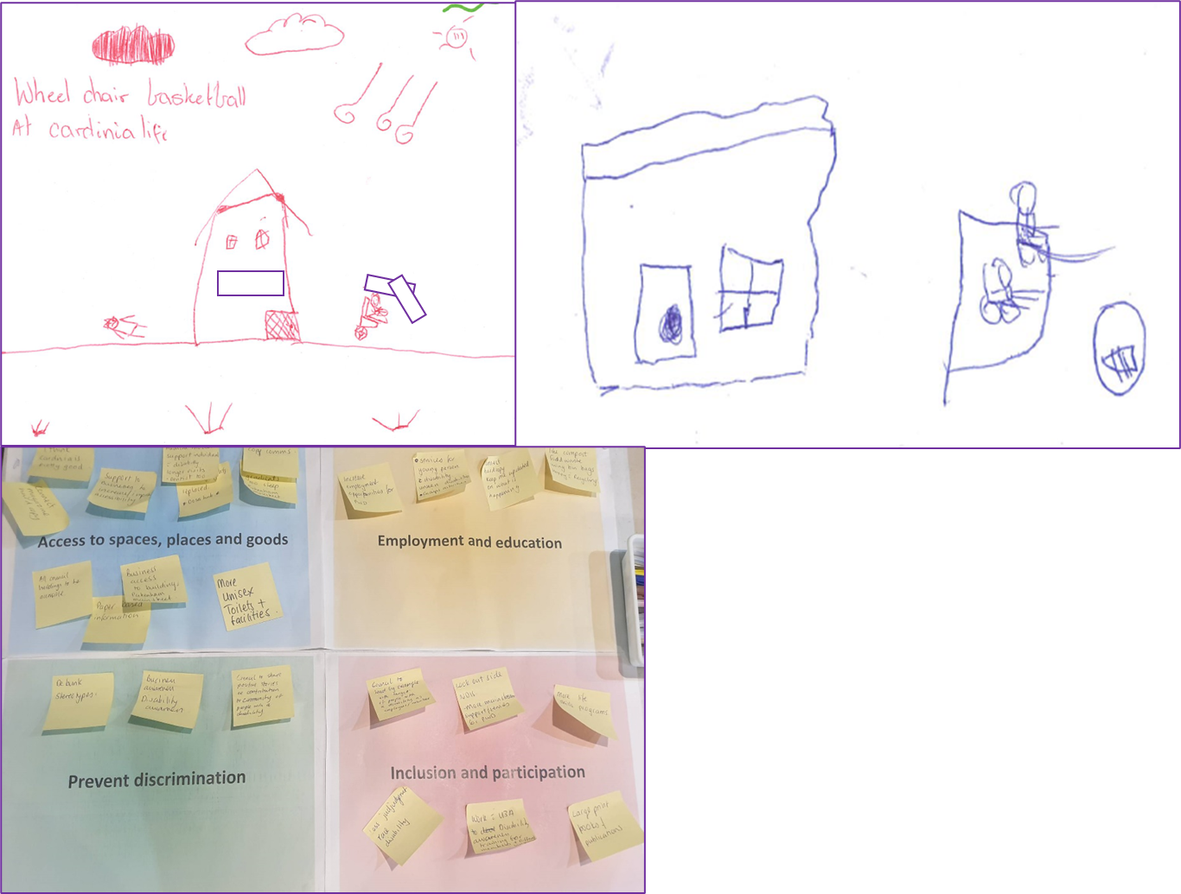
Figure 9 Images from community consultation

Action plan
This Access and Inclusion Disability Strategy Action Plan sets out the steps that Cardinia Shire Council will take to make the products and services we deliver to the public more accessible and inclusive, as well as outlining the steps Council takes to make our corporate culture and practices more inclusive. The following table outlines the overarching objectives of the disability action plan:
 | Priority area | Objectives
 | Create accessible spaces and places | People with disability have access to local services
 |  | Create accessible buildings, new and refurbishments
 |  | Accessible outdoors, parks, and footpath networks
 |  | Accessible local businesses and communities
 | Inclusive culture reflecting our diversity | Community and business disability awareness
 |  | Communicate information to everyone
 |  | Participation in sport
 |  | Participation in community events, groups
 | Living working and learning locally | Supporting people with disability to employment opportunities and celebrating successes
 |  | Become a disability employment leader
 |  | Advocate for housing options for people with disability
 | Preventing discrimination | Change community attitudes
 |  | Celebrate diversity
 |  | People with disability feel safe and welcome

Implementation
Within the Community and Family Services group, the Access and Ageing team is responsible for monitoring the implementation and reporting of the disability action plan.
Each action item is owned by a Cardinia Shire group. The group is responsible for delivering the action item within the allocated timeframe.
To meet Councils’ legislative requirements, the action plan progress is reported in the Cardinia Shire Council annual report. An annual update is provided to Council’s senior leadership team and to council briefing for the duration of the plan.

Results page

Figure 11 Survey demographics

Figure 12 Township representation

Figure 13 Age group of survey participants

http://www.mav.asn.au/what-we-do/policy-advocacy/social-community/disability
World Health Organization 2001. The International Classification of Functioning, Disability and Health (ICF). Geneva: WHO. http://www.who.int/classifications/icf/en/
https://profile.id.com.au/cardinia
https://forecast.id.com.au/cardinia
2017, Cardinia Shire’s Liveability Plan, 2017-2029.
ABS 2019a. Sources of data for Aboriginal and Torres Strait Islander peoples with disability, 2012–2016. ABS cat no. 4431.0.55.004. Canberra: ABS. https://www.abs.gov.au/ausstats/abs@.nsf/mf/4431.0.55.004
ABS 2019b. Disability, ageing and carers, Australia: summary of findings, 2018. ABS cat no. 4430.0. Canberra: ABS. https://www.abs.gov.au/ausstats/abs@.nsf/mf/4430.0
https://www.crimestatistics.vic.gov.au/family-violence-data-portal/family-violence-infographics/victoria-police-family-violence-incidents
https://profile.id.com.au/cardinia/unpaid-care
https://content.legislation.vic.gov.au/sites/default/files/2020-10/06-23aa042%20authorised.pdf
https://content.legislation.vic.gov.au/sites/default/files/2020-04/20-9aa003%20authorised_0.pdf
https://content.legislation.vic.gov.au/sites/default/files/2020-04/20-9aa003%20authorised_0.pdf
Cardinia Shire Council Liveability Plan 2017 – 2029.
People with disability in Australia, 2020. Australian Institute of Health and Welfare.
2Cardinia Shire Council (2017) Strategic Directions Paper, For development of the Municipal Public Health and Wellbeing Plan, October 2017.
SAHS Council.
People with disability in Australia, 2020. Australian Institute of Health and Welfare.

